http://www.tellme1st.net/energy-resources/info-book/info-book-200308d.html

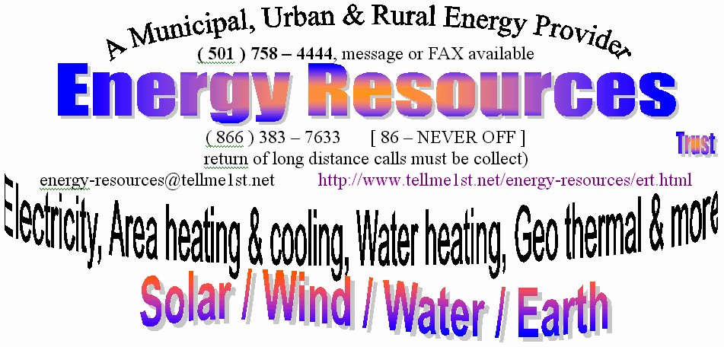
Energy from the Sun
with your own electrical energy system

Summer, Fall, Winter & Spring  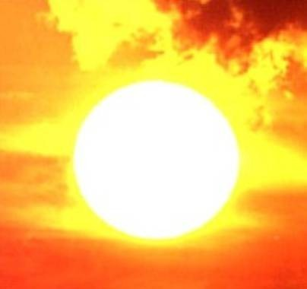  The power of the Sun, water & wind | Use the Sun to make electricity for your house. -- Use the Wind to make electricity for your house. -- Use moving Water to make electricity for your house.  Use the Sun and/or Earth to heat your home. -- Use the Sun and/or Earth to heat your water. -- Use the Earth to cool your home.  Use modern high tech products to construct your home and protect it. -- You have imagined these things, but always find an excuse why it will not work.  You say it costs too much. -- You say it is too complicated. -- You hear rumors and believe them.  With other aspects of your life you practice exactly that which you resist, for making yourself independent.

Reliable
Systems which are battery based and Off Grid provide nearly perfect reliability. They are not subject to weather related utility outages and other delays of power
restoration.

Independence
An Off Grid electrical system provides complete energy independence. You control how much power is produced and used. Owning and operating the energy
supply instead paying monthly to the electric company and having nothing to show for it.

Available
One of the best reasons for having an independent electrical system is the absence of utility supplied power. Either the cost of getting the poles to your home are too
costly or the power company turns it off.

Initial Cost
Whether you buy outright or get a note to pay for it, owning your own energy system is less costly than paying the electric company monthly forever. However you pay for your own system, you will pay today’s price and not be subject to price hikes. Many systems can be paid by note in 10 – 30 years. You can also choose to sell what you produce to the electric company. It is called “net metering” and turns backward the electric meter. Your own system is less costly than renting from the electric company. Many people every day are relying solely upon their own energy systems. Some use the electric company as a backup, which is a turn of the tables. When your system is paid at today’s prices, you start seeing less costs than what there was on the grid.

Renewable Energy (Environmentally Friendly)
Electrical systems which stores power in batteries is good to harness the power of the sun, wind and water. Photovoltaics (PV), wind power and hydro are all used as production and charging sources for Off Grid electrical systems. Each of these is a renewable energy and storable. Solar, wind and water electrical systems do not usually use or burn fuel and thereby do not pollute. Similar heating and cooling systems are likewise not polluting.

INDEPENDENCE – is being in authority of your own life and your own affairs – not governed by another, not relying on another.

DEPENDENCE – being in subjection to someone else for your life and your affairs – being determined by someone else.

LIBERTY – action going beyond normal limits.

PERMISSION – consent from another person.

MASTER – one in authority.

SLAVERY – own by or serving another.

"In the beginning of a change, the patriot is a scarce man, and brave and hated and scorned. When his cause succeeds the timid join him, for then it cost
nothing to be a patriot." -- Mark Twain

The same can be said for a multiple of arenas of change. The people who make a change to independence of energy and such are novelties and ridiculed. It was that way with the car, with electricity wires being strung over the countryside, with going fast in cars (your breath would be sucked from you), and many or most advents in human history. There are many people who have installed various energy systems and enjoying them, while their friends and family are saying all the reason it cannot be done. Did you know that certain rules of physics say a Bee cannot fly? Yet, the Bee flies very well.

While there are some greater efforts required of you in an independent energy system, the rewards are greater.

The issues are ---

Ownership or rental. <> Self control or slavery

Reduce your expenses, improve your efficiency, be the envy of your friends and family. <> Learn that you can own your electricity rather than renting it from the electric company. <> See how renting from the electric company will cost over 60,000.00 (for average middle class home & assuming the rates do not rise), and how owning a system can cost the same or less. <> Consider not having blackouts or brownouts. Wonder at the independence. <> Heat and cool your home with the temperature of the Earth, and save.

Never shingle again
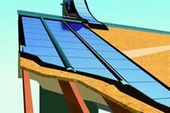…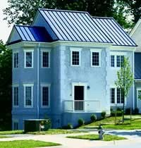
Amorphous solar electric panels instead of shingles

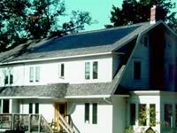…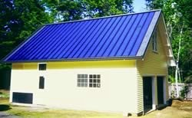
Size of home does not matter. Amorphous solar electric panels instead of shingles.

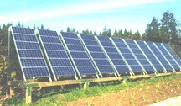…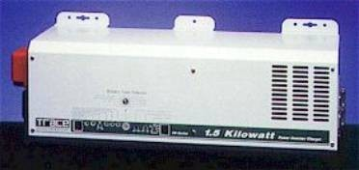
Solar panels convert light energy (photons) into DC electrical energy. This energy can be used immediately or stored for later use. | Inverters convert DC power to AC power, they can start with 12, 24, 48, 96 (& others) volts DC and make 120 or 240 (& others) volts AC. All with the energy to power your home or office.

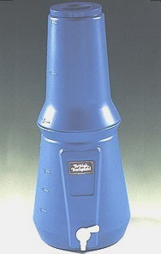…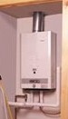
Water filters can make muddy river water perfectly drinkable. | These do not heat water when you are not home or not using water. They only heat water when the hot water line is flowing Then when the water is stopped, the heating stops. It is realistic to save 35% energy costs compared to a tank heater.  NEVER RUN OUT OF HOT WATER

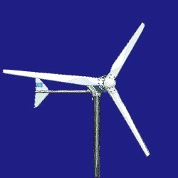…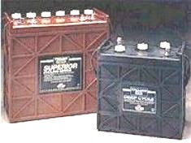
Wind powered generators and water powered generators convert the motion (movement) of wind and water to electrical energy. This energy can be used immediately or stored for later use. Wind and water power can be less expensive than solar for making electricity. | Batteries store the energy generated from any number of sources and keep it till required later by appliances and equipment of your using. They can be used to hold energy for hours or days or weeks. The more battery storage capacity the greater the cost.

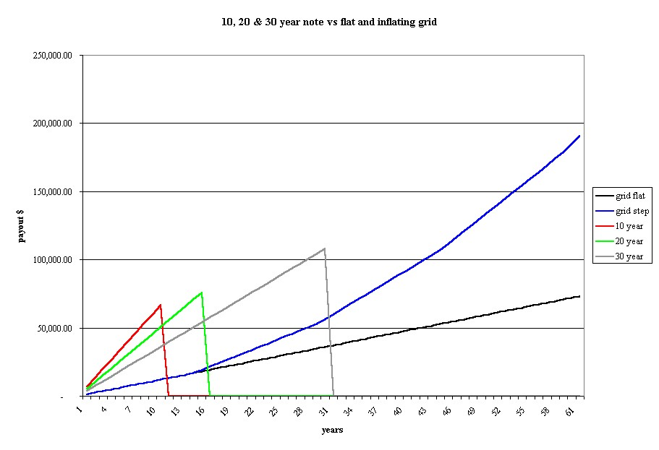
(price paid on the left & years on the bottom)
(right click on the graph to save the image and view/printing it in your favorite imaging program)

The above chart represents possible AGGREGATE values for a home/office that has an electric bill of about 100.00 and 3 loans/notes for a SOLAR ELECTRIC GENERATING SYSTEM of about 50,000.00. The 3 loans are a 10 year (red), 15 year (green) & 30 year (pink) compared to what you might pay to the electric company assuming their rates remain as is (black) assuming their rates double on average of every 10 years (blue). This chart is general and not intended to be what you may have/need.

-- The relative relationship of a system will vary a little with different usages and sizes.

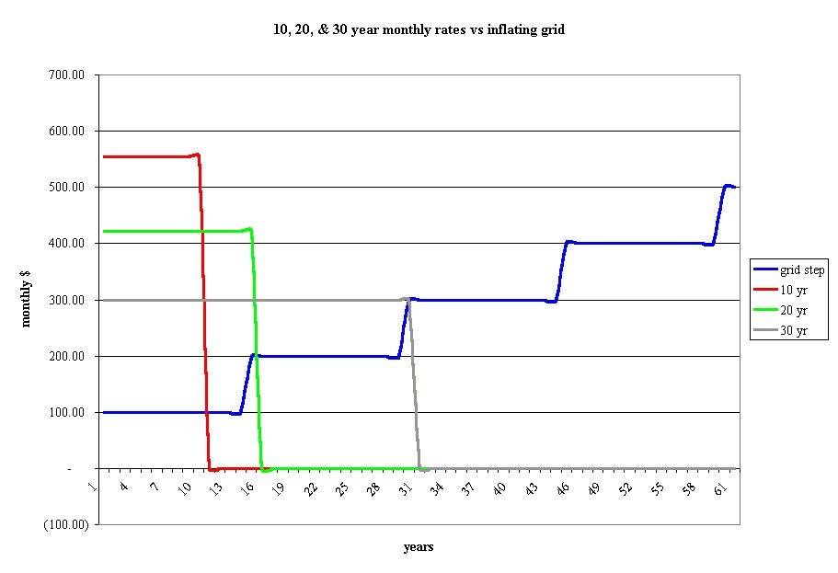
(price paid on the left & years on the bottom)
(right click on the graph to save the image and view/printing it in your favorite imaging program)

The above chart represents possible MONTHLY values for a home/office that has an electric bill of about 100.00 and 3 loans/notes for a SOLAR ELECTRIC GENERATING SYSTEM of about 50,000.00. The 3 loans are a 10 year (blue), 15 year (red) & 30 year (pink) compared to what you might pay to the electric company (black) assuming their rates double on average of every 10 years. This chart is general and not intended to be what you may have/need.

-- The relative relationship of a system will vary a little with different usages and sizes.

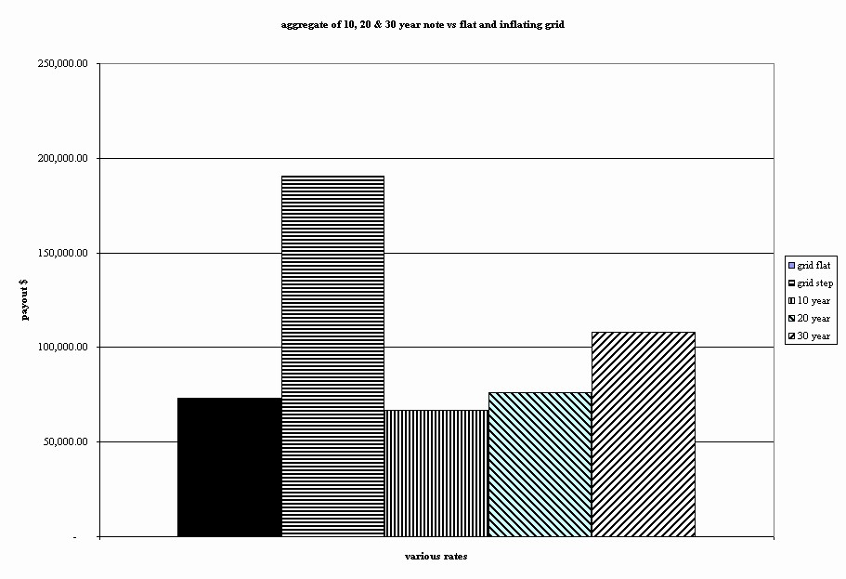
(price paid on the left & years on the bottom)
(right click on the graph to save the image and view/printing it in your favorite imaging program)

The above chart represents possible AGGREGATE values for a home/office that has an electric bill of about 100.00 and 3 loans/notes for a SOLAR ELECTRIC GENERATING SYSTEM of about 50,000.00. The 3 loans are a 10 year (red), 15 year (green) & 30 year (pink) compared to what you might pay to the electric company assuming their rates remain as is (black) assuming their rates double on average of every 10 years (blue). This chart is general and not intended to be what you may have/need.

-- The relative relationship of a system will vary a little with different usages and sizes.

Wait ….. Wait ….. Wait ….. Wait ….. Wait

When you are figuring your monthly bills, do not forget to subtract the amount per month (in this example 100.00) you will not be paying to the electric company. Using the monthly note prices in the above graph, they are not additional costs in addition to the electric bill, they are the electric bill. So MINUS 100.00 (in this example) that used to go to the grid company.

No matter the cost, a basic question is TO WHOM WILL YOU PAY THE MONTHLY BILL? Another question is what do you have to show for all the money spent? With “grid” power, you have NOTHING. With your own system, you have SOMETHING.

With your own energy system, you can move it to a new location, or you can sell it with the old and use it as an improvement which increases the value of the home, whereby making your selling price greater.

Imagine if you did not pay the monthly “note” for your own system, who is going to shut off your electricity for nonpayment – no one.

Remember that all energy systems are upgradeable and expandable.

You can start with a smaller system now, to power a few lights and refrigerator. These items will run daily on your own system and you monthly “grid” bill is reduced by an amount to reflect the switch. If and when the neighborhood is without power, and of course most of your house, you will still have the fridge and enough lights to move around the house, just like any other day.

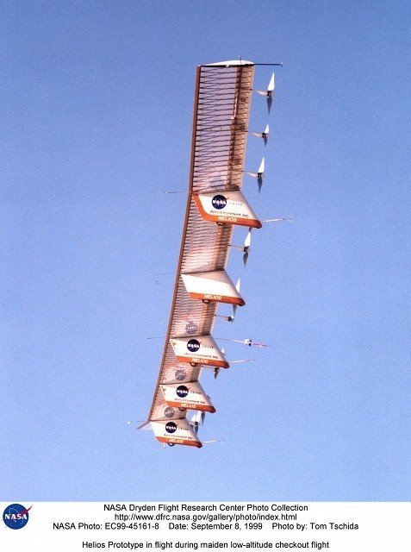…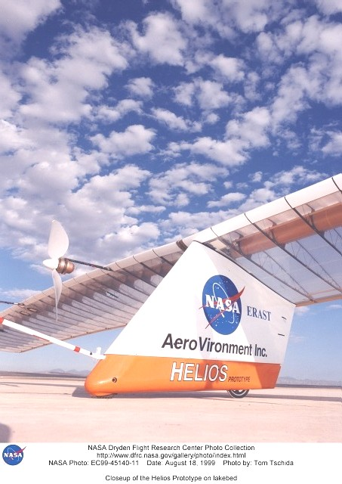
The preceding images are of the NASA Dryden flying wing called Helios. It is powered entirely of solar panels, which power the motor that turn the propellers. Commercial grade solar cells used in homes run at about a 12% - 14% efficiency rate. The cells used on the Helios are 18% efficient. Each of the cells on the Helios is 1.25"x2.75". These solar cells deliver about 35KW, to power this solar plane. By comparison, an average home may need about 4KW – 10KW.
Your house could be flying.

The following is an example of a pricing statement from a supplier showing why pricing is difficult to keep track.

Some reasons why it is difficult to keep up-to-date prices.

Trace, Statpower, and Heart – special notes: Xantrex (the owner of these 3 companies) will no longer allow us to show any pricing but full list price for their profducts. Since all of our pricing is in a database, and there is no possible way to prevent our actual selling prices from showing uyp online, we have REMOVED all pricing for these products. Please note that Xantrex AGAIN raised prices as of May 1, 2001.

This means that you, our customers, can NO LONGER order any of the above products online. Although we disagree with the policies set by Xantrex, at this time we have no choice but to comply.

Consequently, we have removed all of our ACTUAL pricing information on Trace, Statpower, and Heart products.

We will still give the lowest prices possible on all these products, but you will no longer have the convenience of ordering online nor of seeing what your actual price is without getting a quote from us. Since this will increase our overhead costs considerably, we may have to increase prices on most Trace products. If you have any question on this policy, please contact Xantrex/Trace, not us.

For prices on all these products, please email us if possible – although we will give pricing if you call, we expect that this policy will impact our ability to handle the volume of calls that we expect to get. For pricing call.

Also, since products are sometimes replaced with new models, the older models can sell much lower than normal and must be checked occasionally. Sometimes, selected models are put on special quantity pricing and this can be a benefit. But there is no easy way to know all of these facets all the time. When you decide to install a system, the best prices can be garnered from the industry at that time. This may get you a different model than your neighbor, but still a very good product.

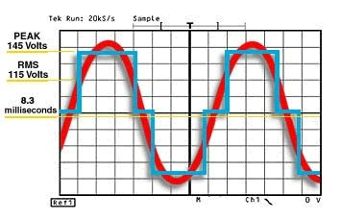 | This graph shows the relative comparison of “sinewaves” SW (which is like what you have with “grid” power) and what is called “modified sinewaves” MSW (which are really modified squarewaves, sometimes called quasi-sine wave). The MSW is more efficient to operate than a SW, but some equipment will not run properly on a MSW and must have the SW.

What can you run from a MSW inverter?
Pretty much anything, but there are a couple of exceptions:

The AC output waveform of the some inverters is called a "quasi-sine wave" or a "modified sine wave". It is a stepped waveform that is designed to have characteristics similar to the sine wave shape of utility (“grid”) power. A waveform of this type is suitable for most AC loads, including linear and switching power supplies used in electronic equipment, transformers, and motors. The modified sine wave produced by the inverter is designed to have RMS (root mean square) voltage of 115 volts, the same as standard household power. In general, any device that senses either voltage peaks or zero crossings could have problems when running from this waveform. Examples of these devices are motor speed controllers employing triacs. An example of these might be breadmakers, and some small battery rechargers that do not incorporate a transformer between the AC power source and the load. Examples of the chargers would be those commonly used in battery operated tools, such as drills.

Typical warranties (not absolute) & expected lifespans

~~Solar.panels | 20 year | more than 20 years
~~Inverters | 6 years | being electronic, expectations are long like other non-moving-part appliances (clocks, TV’s, computer monitors, etc)
~~Batteries | 5 – 15 years | reports have 5 years batteries lasting 20 years

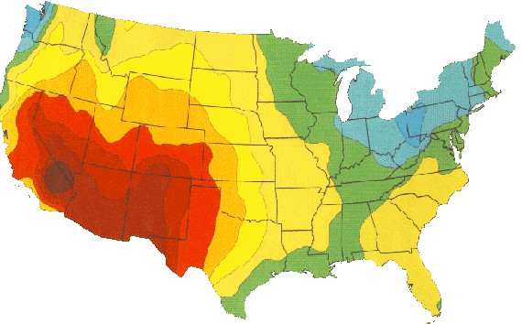

Average annual solar exposure.

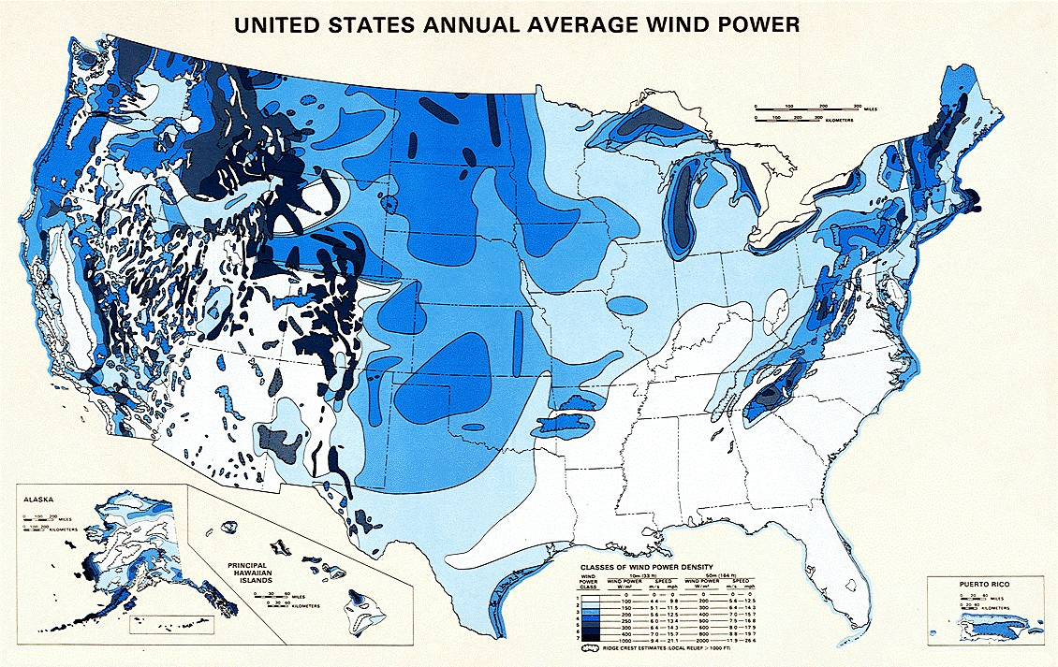
Average annual wind

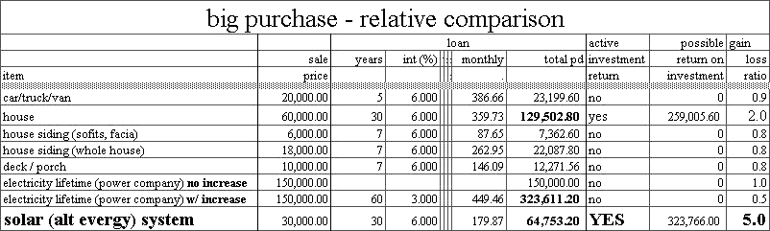

You are already committed to monthly payments for home, telephone, water and electric. These are lo-o-o-o-ong term (life) commitments. With electric and other energy related systems you can make a different commitment, like the one for your car. You only pay it for a few years, then you own it. Do not keep paying till you die. Buy it, own it, and never owe the electric company again.

You can have (or start with) a partial system to power part of your home/office, like a refrigerator, a few lights and something else. You can add more later.

Electricity or new car?

A new car will cost you between 15,000 to 60,000 bucks. Most people do not need a new car, but are more likely to get one for image. If the same funds, for the same time, were spent on an energy system, the investment would last the rest of your life and be an investment and inheritance. You may never have another electric bill.

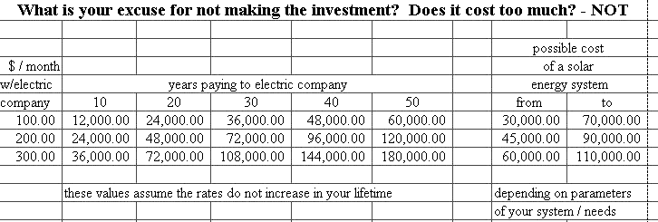

April 2002
revised: August 2003
revised: April 2004
mailto: energy-resources@tellme1st.net

